Cumulative Payments and Home Equity (Fixed) - Full Answer

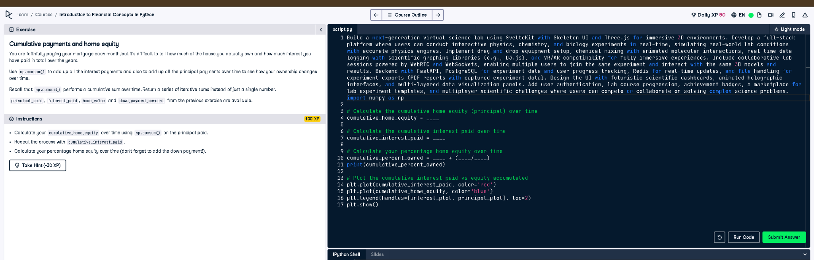

# Full Code Answer:

import numpy as np  
  
# Calculate the cumulative home equity (principal) over time  
cumulative_home_equity = np.cumsum(principal_paid)  
  
# Calculate the cumulative interest paid over time  
cumulative_interest_paid = np.cumsum(interest_paid)  
  
# Calculate your percentage home equity over time (fraction, not multiplied by 100)  
cumulative_percent_owned = down_payment_percent + (cumulative_home_equity / home_value)  
print(cumulative_percent_owned)  
  
# Plot the cumulative interest paid vs equity accumulated  
plt.plot(cumulative_interest_paid, color='red')  
plt.plot(cumulative_home_equity, color='blue')  
plt.legend(handles=[interest_plot, principal_plot], loc=2)  
plt.show()

# Question:

How do we correctly calculate cumulative home equity percentage and avoid multiplying by 100 when not needed?

# 20-word Explanation (Question):

Calculating equity as a fraction avoids unnecessary scaling by 100, representing ownership proportion correctly throughout mortgage term.

# Answer:

We add down_payment_percent to the cumulative_home_equity/home_value ratio, ensuring the percentage remains a fractional value over time.

# 20-word Explanation (Answer):

Using down_payment_percent plus cumulative_home_equity divided by home_value ensures a correct fractional home ownership representation over time.